**Name Wajahat Ali Basharat**

**Roll No 0001**

**Question NO 1**

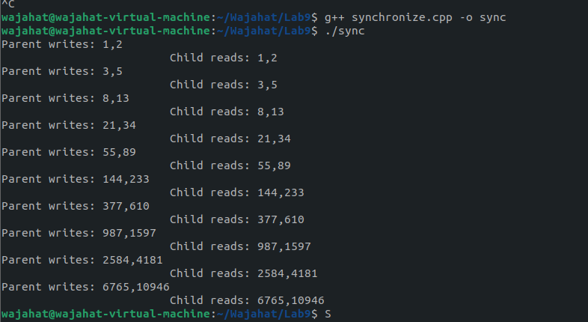

In this task, the parent process is writing and the child process is reading the values. And both processes are synchronized. When the parent writes something, it waits for the child to read that, and then the parent writes the next data.

Share memory provides an efficient way of communication via the sharing of the data that resides in memory.

The Shared memory can be accessed in a non-serial (random) manner. It means that semaphore or other synchronization methods must be used to coordinate access to shared memory segments.

shmget is used the create and gain access to an existing segment.

shmctl is used to obtain the status of a memory segment, set permissions, and remove a shared memory segment.

shmat and shmdt are used to attach and detach shared memory segments.

mmap system call is used to map the virtual memory space of a process to a file. It is very useful since the data is in a file, and it won’t lose after the process exists.

**Question No 2**

1. Compiler and run the above code and notice the result.

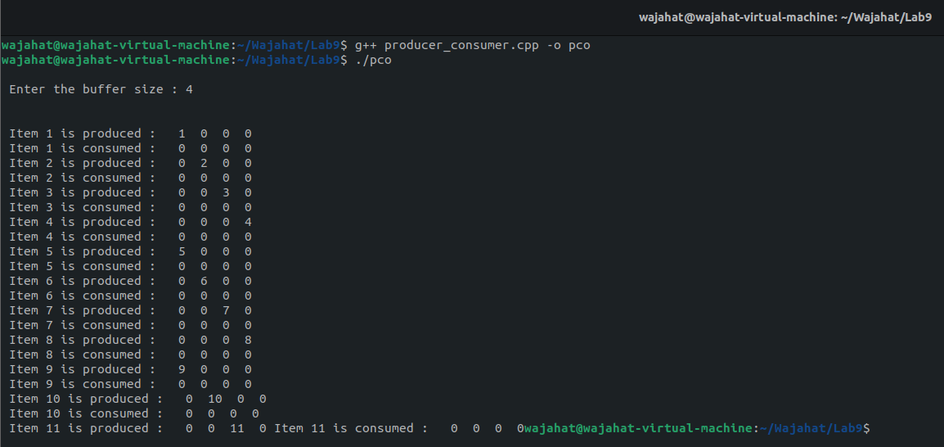

In the producer-consumer problem, there is one Producer that is producing something and there is one Consumer that is consuming the products produced by the Producer. The producers and consumers share the same memory buffer that is of fixed size.

2. Modify the sleep in the child’s process to sleep(2). What happens now?

In this task, the producer execute normally its code but the consumer waits for 2 seconds, and then it consumes that’s why it consumes later.

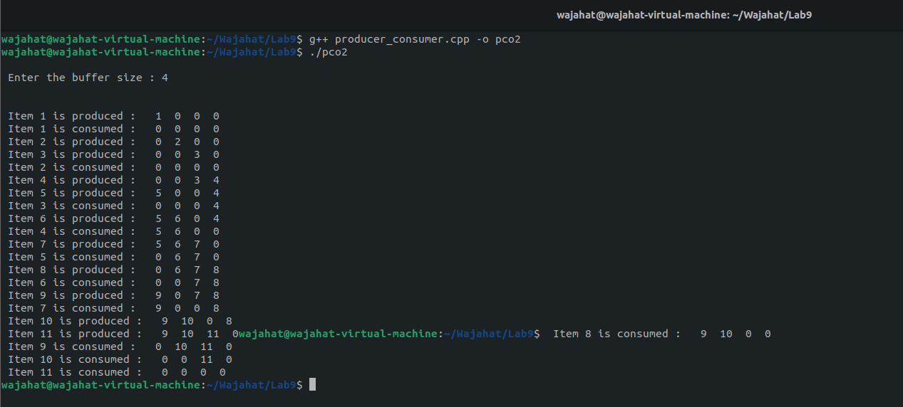

1. . Modify the sleep in the parent process to sleep(2). What happens now?

In this task, the producer produces 2 seconds later while the consumer consumes normally.

